# Leslie Kahler

Cybersecurity Bootcamp

Final Project

September 8, 2021

# **Red Team: Summary of Operations**

## **Table of Contents**

* Exposed Services
* Critical Vulnerabilities
* Exploitation

### **Exposed Services**

Nmap scan results for each machine reveal the below services and OS details:

$ nmap -sV -A 192.168.1.110

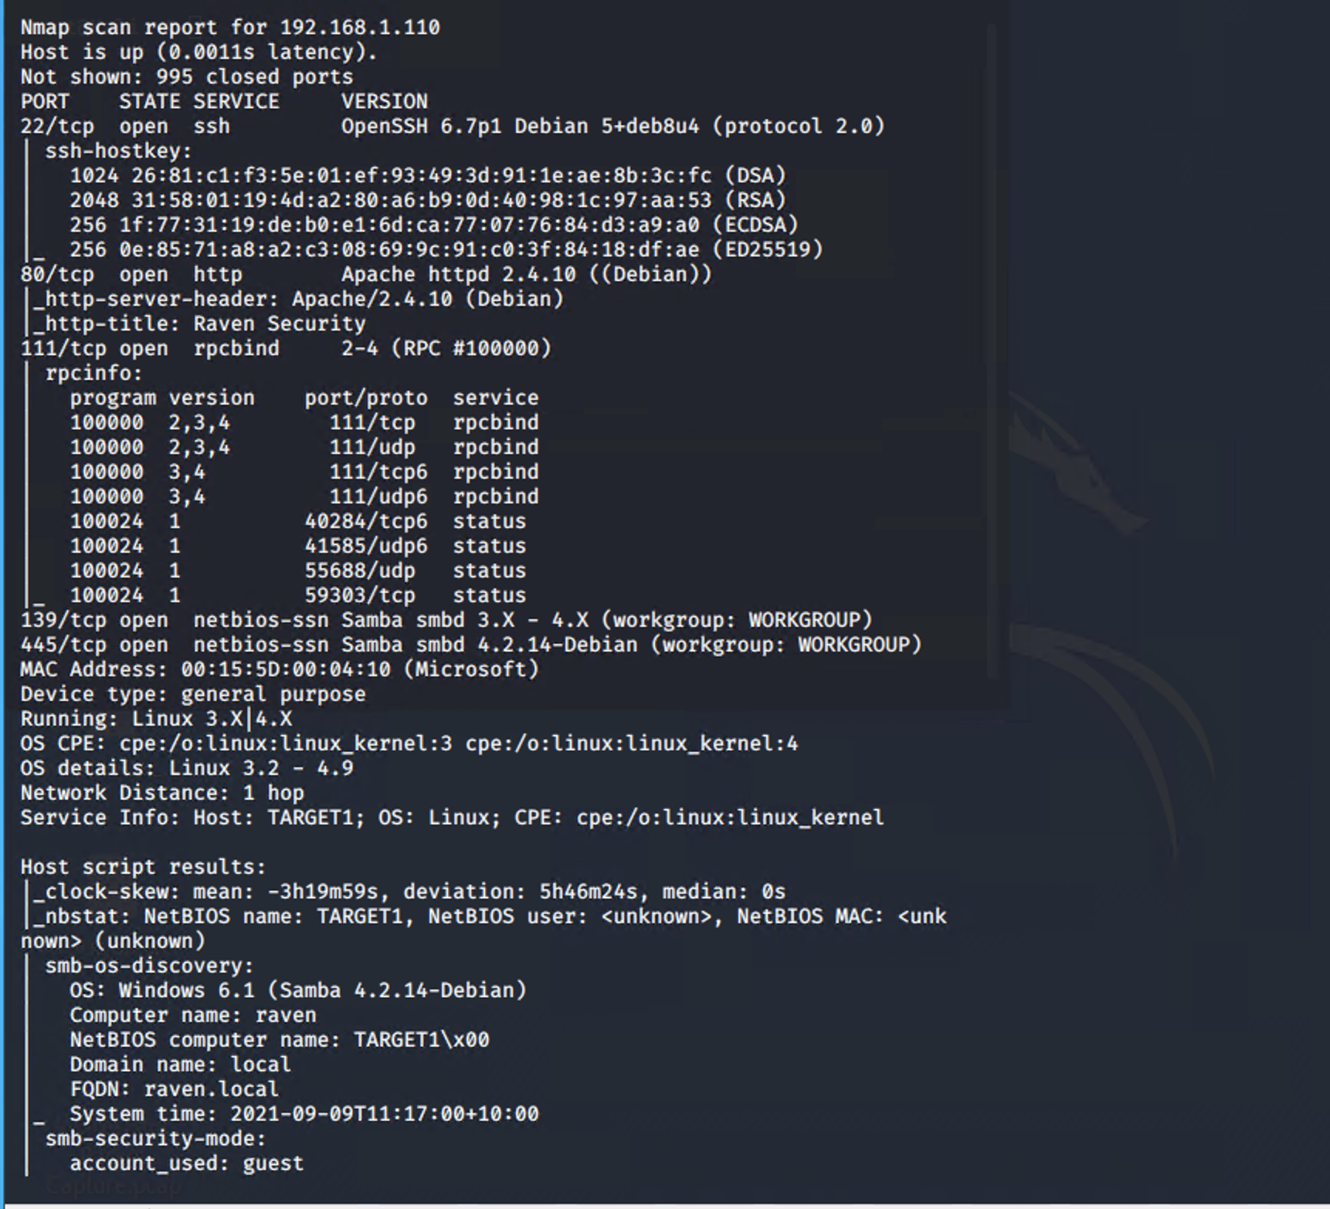

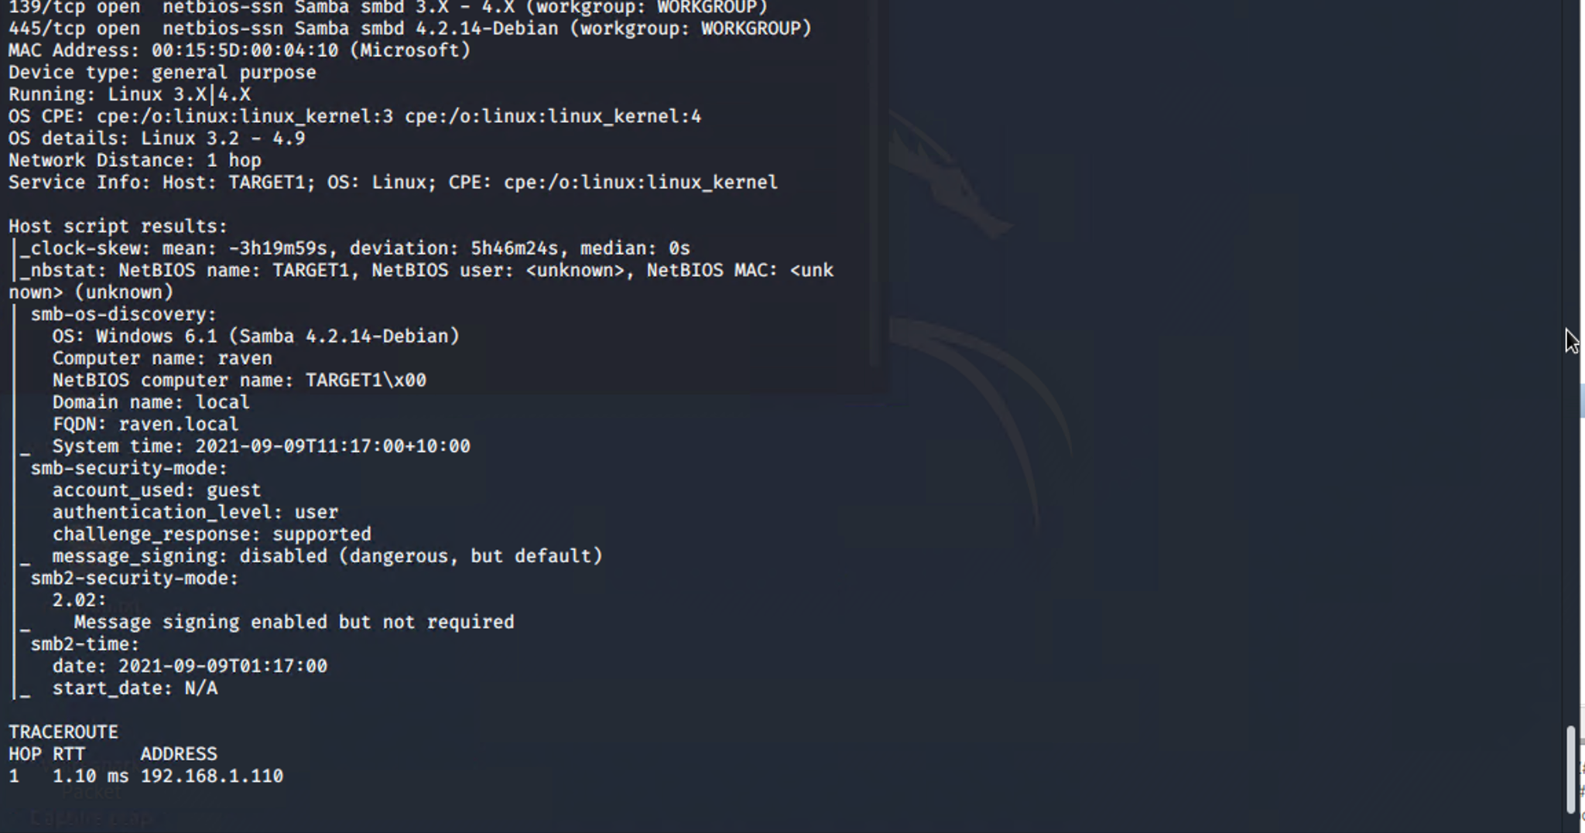

This scan identifies the services below as potential points of entry:

* Target 1
  + OpenSSH v6.7p1 22/tcp
  + Apache v2.4.10 80/tcp
  + Samba v4.2.14 445/tcp, 139/tcp

The following vulnerabilities were identified on each target:

Target 1

* + Misconfiguration of steven user to run python as sudo
  + Misconfiguration of michael user with password the same as his name
  + OpenSSH configured with weak authentication, password only.
  + Open port 22/tcp was not filtered, accessible publicly.
    - CVE-2015-5600 -Brute Force Attack - 8.5 severity
    - EDB-ID 40888 -DDoS Exploit - 7.8 severity

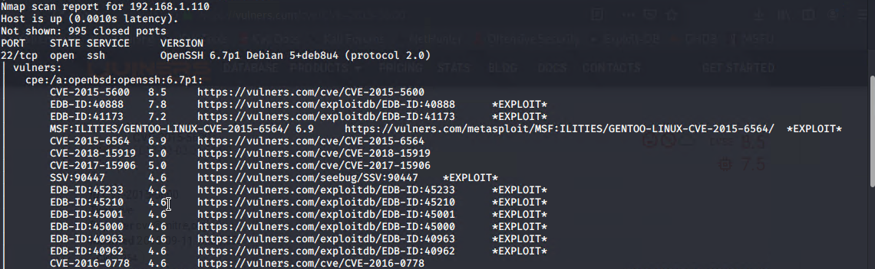

* + Open ports 139/tcp and 445/tcp
    - CVE-2017-7494 - Samba exec code vulnerability - 10.0 severity
  + Open port 80/tcp
    - CVE-2017-3167 - Apache authentication bypass vulnerability - 7.5 severity

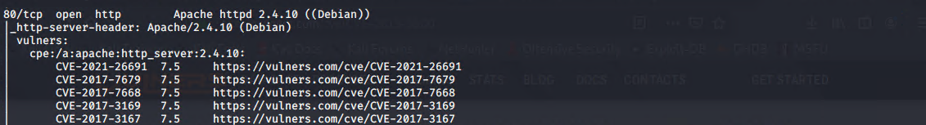

* + Misconfiguration of Website with sensitive data publicly available in source code.

*Command: nmap -sV --script vulners 192.168.1.110*

* Port 22:

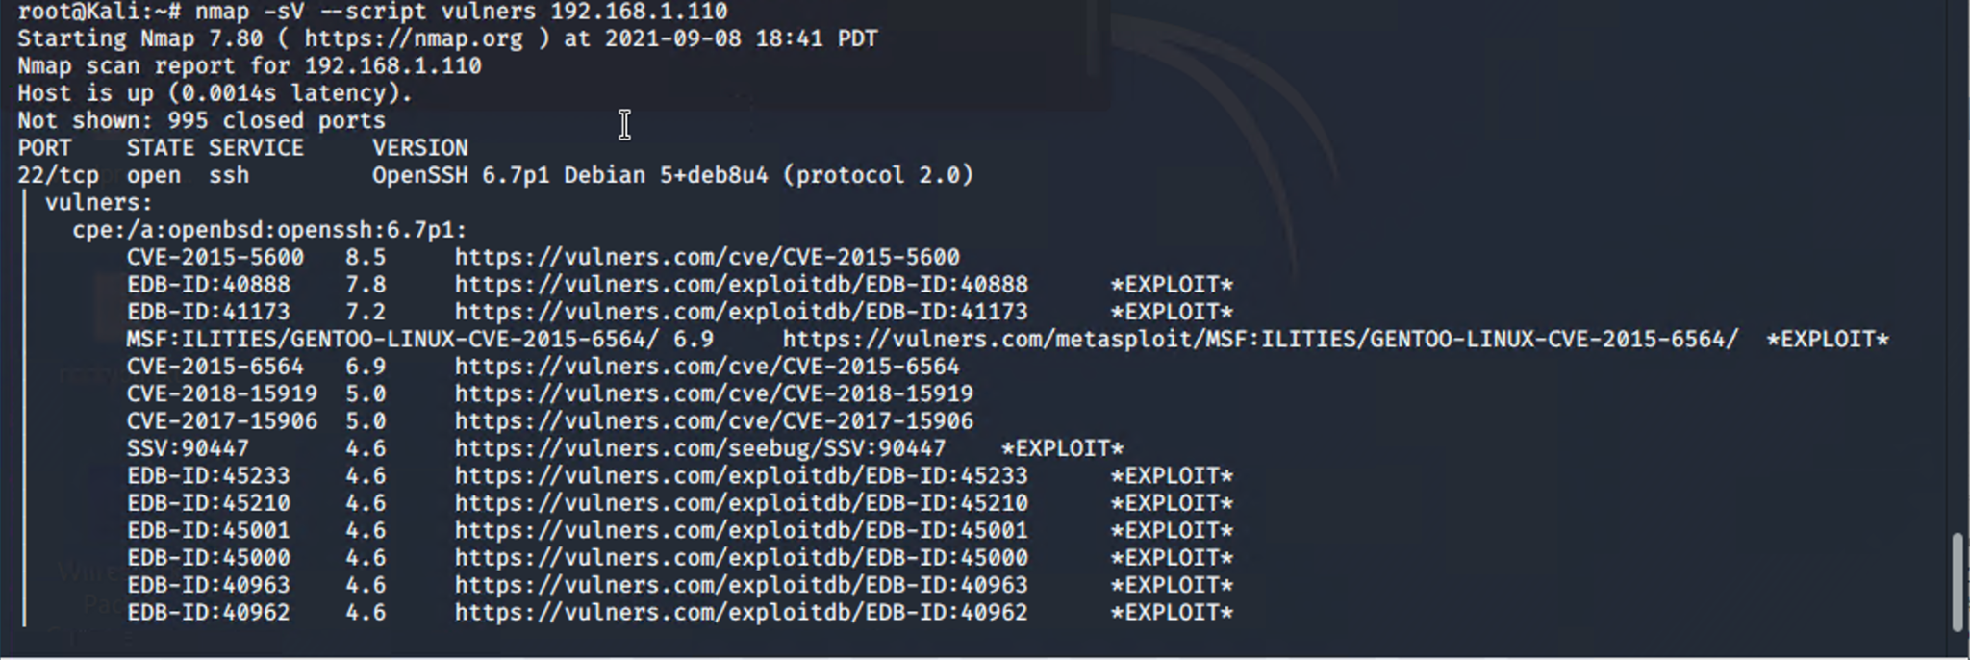

Port 80: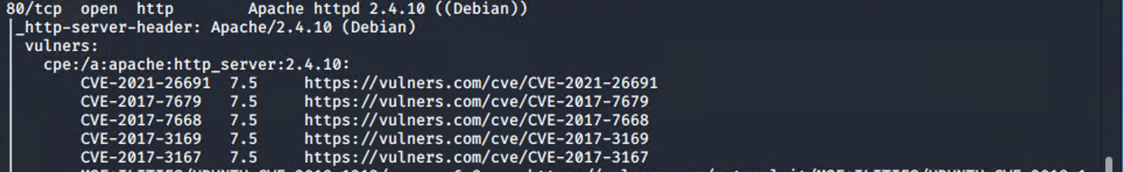

Port 139 and 145: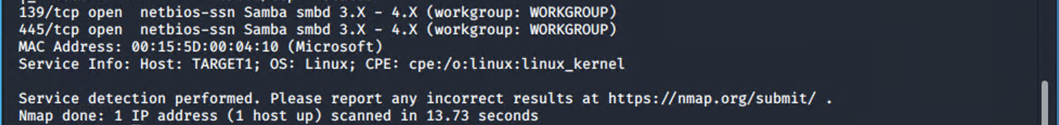

### **Exploitation**

The Red Team was able to penetrate Target 1 and retrieve the following confidential data:

* Target 1
  + flag1.txt: b9bbcb33e11b80be759c4e844862482d
    - **Exploit Used**
      * Was able to SSH into Michael’s account by guessing his username
      * Sensitive data is publicly available once you have access to his account
      * Used the web browser's console to view source code
      * Initially, this flag was found with grep once logged in via SSH as Michael
      * *grep flag1 /var/www/html/*

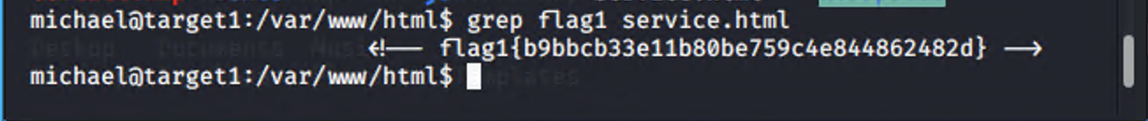

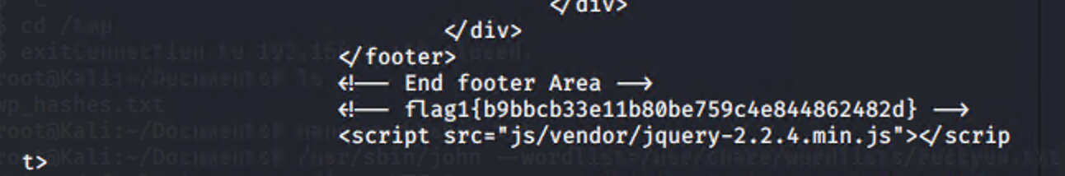

* + flag2.txt: fc3fd58dcdad9ab23faca6e9a36e581c
    - **Exploit Used**
      * Weak SSH authentication
      * Once connected via SSH as Michael, we can find the flag by looking in the /var/www file
      * *Cd /var/www*
      * *Cat flag2.txt*

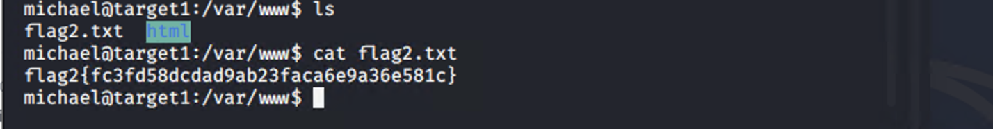

* + flag3.txt: afc01ab56b50591e7dccf93122770cd2
    - **Exploit Used**
      * While SSH’d into Michael’s account, access to the MySQL username and password was accessible in the *wp-config.php* file located in */var/www/html/wordpress/wp-config*

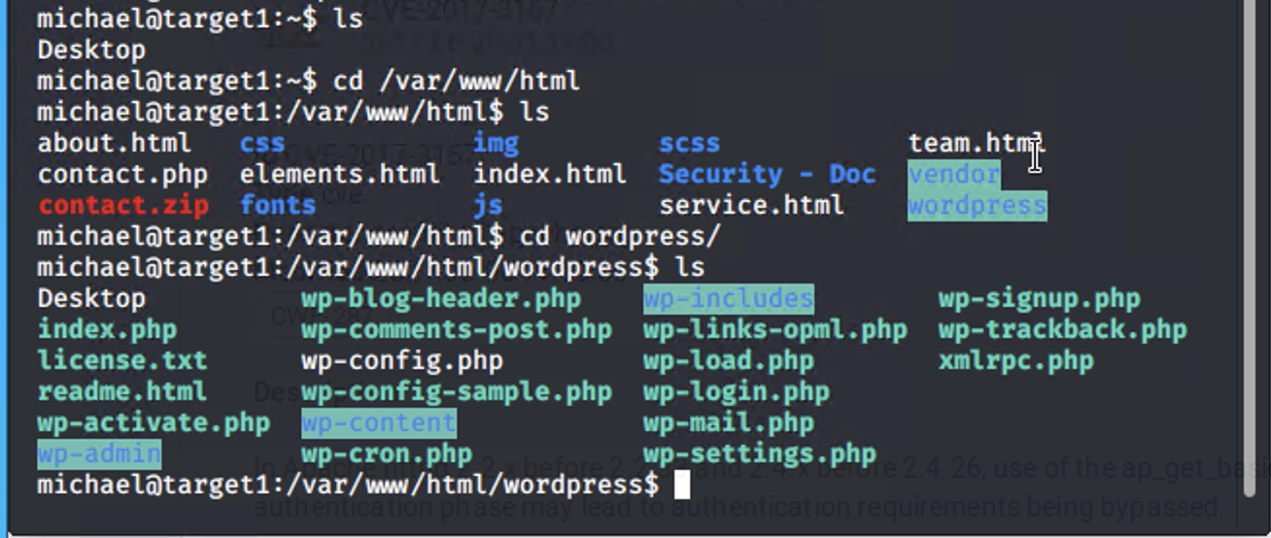

* + - * From here, we are able to log into MySQL.
        + Flag3 and Flag4 were discovered through a search
        + *SELECT post_title,post_content FROM wp_posts WHERE post_title LIKE “flag%”;*

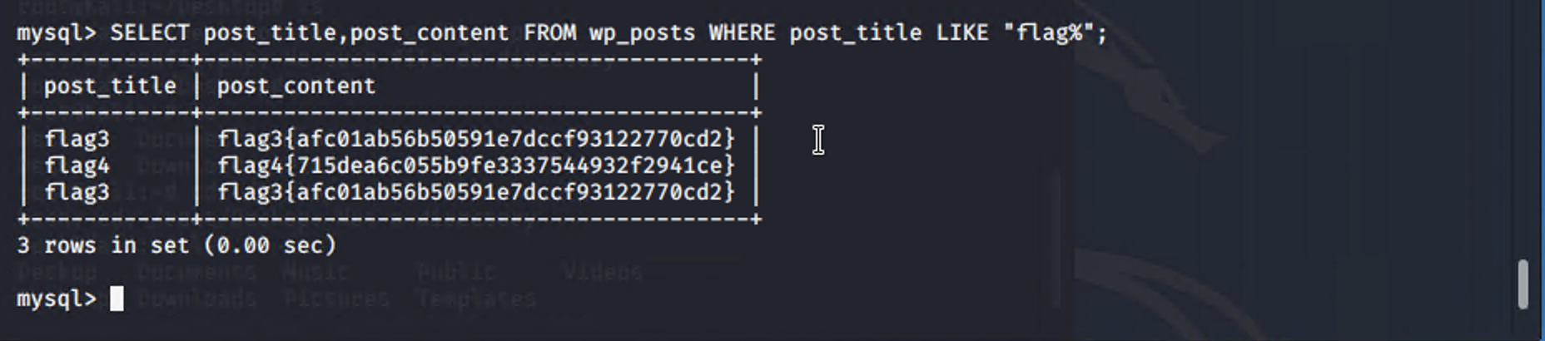

* flag4.txt: 15dea6c055b9fe3337544932f2941ce
  + **Exploit Used**
    - Originally discovered with flag3.txt while logged into MySQL
    - Later discovered after escalating Steven’s account to Root privileges by exploiting the Python command *sudo python -c 'import os; os.system("/bin/sh")'*
      * Once permissions were escalated, access to the Raven file was accessible

